1. **INTRODUCTION** 
   1. Overview

CRM (Customer Relationship Management) applications for schools/colleges are software systems designed to help educational institutions and manage relationships with their students, parents, alumni, and other stakeholders. These applications allow schools to collect and analyze data about these groups to improve engagement and communication.

* 1. Purpose

Customer Relationship Management (CRM) applications for schools/colleges serve the purpose of managing relationships and interactions with students, parents, alumni, and other stakeholders. These applications provide a comprehensive system for schools/colleges to manage and track interactions with their constituents and ensure that they are meeting their needs. **2 Problem Definition & Design Thinking**

* 1. Empathy Map

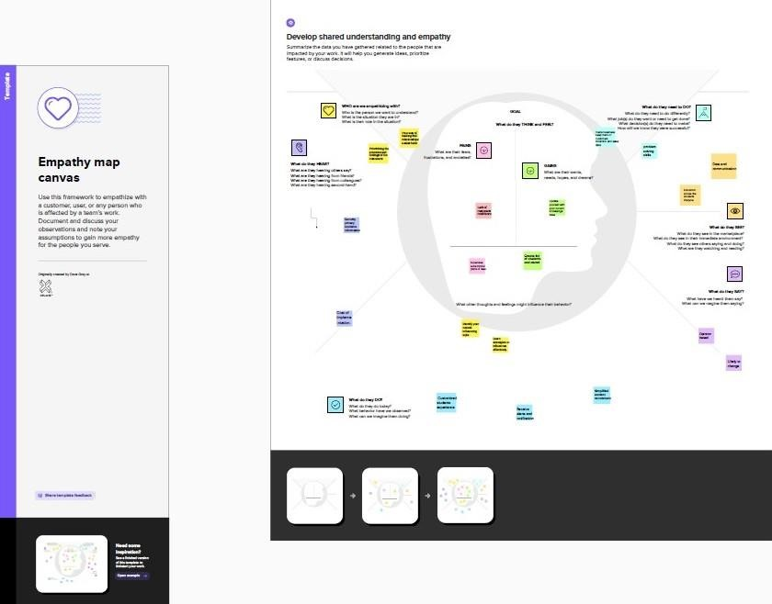

* 1. Ideation & Brainstorming Map

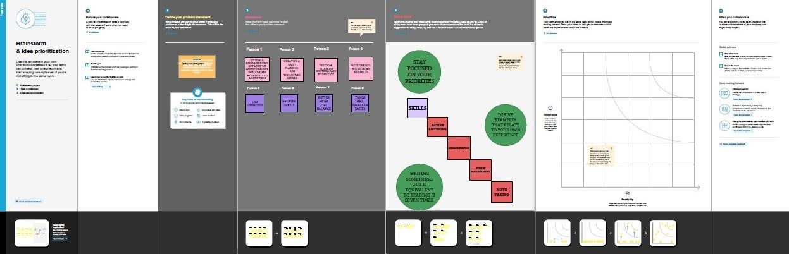

**3 RESULT**

* 1. Data Model:

|  |  |
| --- | --- |
| Object name | Fields in the Object |
| School | |  |  | | --- | --- | | Field label | Data type | | Address | Text Area | | District | Text Area | | State | Text Area | | School Website | Text Area | | Phone Number | Phone | | Number of Students | Roll – up summary | | Highest Marks | Roll – up summary | |
| Student | |  |  | | --- | --- | | Field label | Data type | | Phone Number | Phone | | School | Master – Detail Relationship | | Results | Pick List | | Class | Number | | Marks | Number | |

|  |  |  |  |  |  |  |  |
| --- | --- | --- | --- | --- | --- | --- | --- |
| Parent | |  |  | | --- | --- | | Field label | Data type | | Parent Address | Text Area | | Parent Number | Phone | |

* 1. **Activity & Screenshot**

ACTIVITY 1-OBJECT CREATION **SCHOOL:**

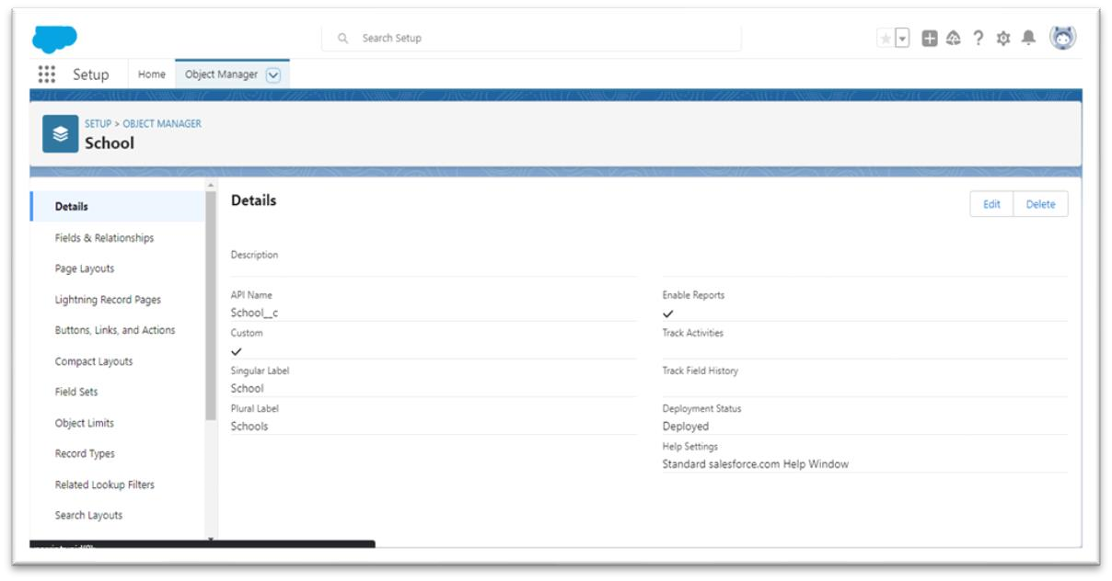

**STUDENT:**

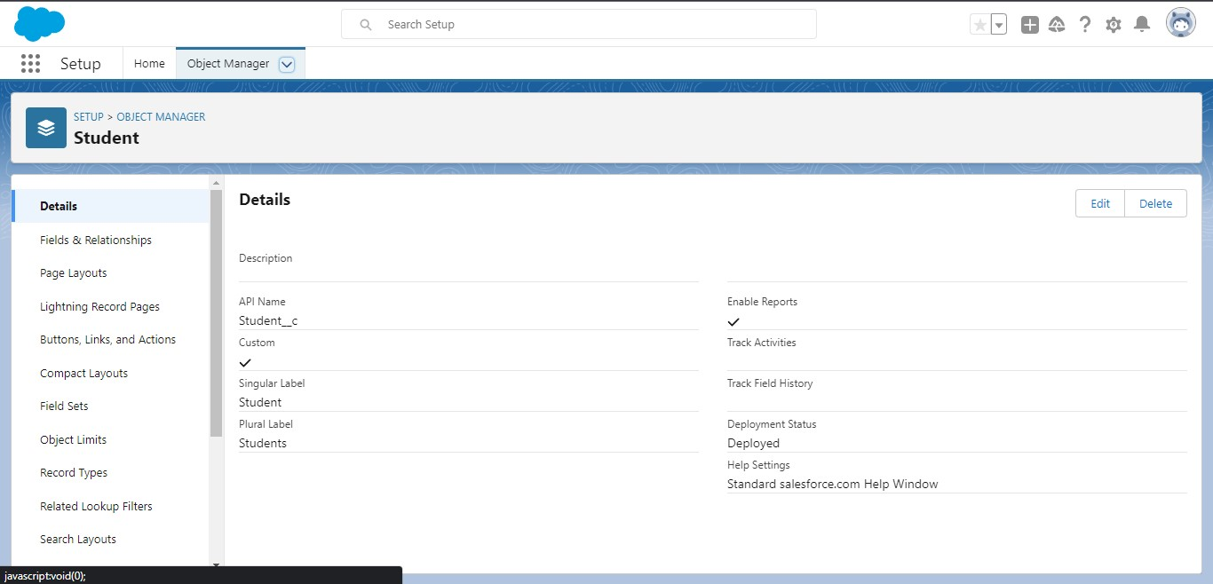

**PARENT:**

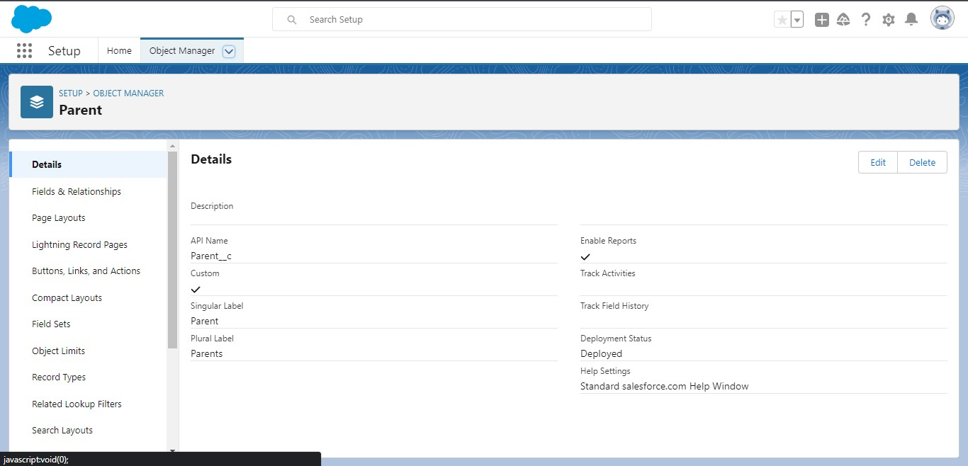

**ACTIVITY 2:**

**LIGHTING APP:**

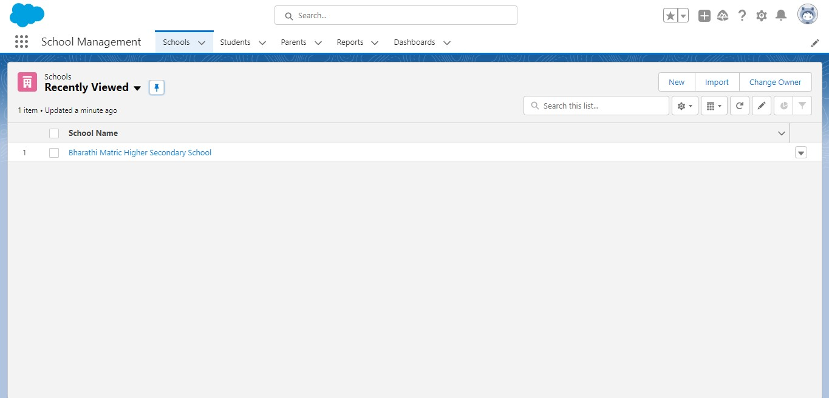

**ACTIVITY 3:**

**FIELDS AND RELATIONSHIP FOR SCHOOL OBJECT:**

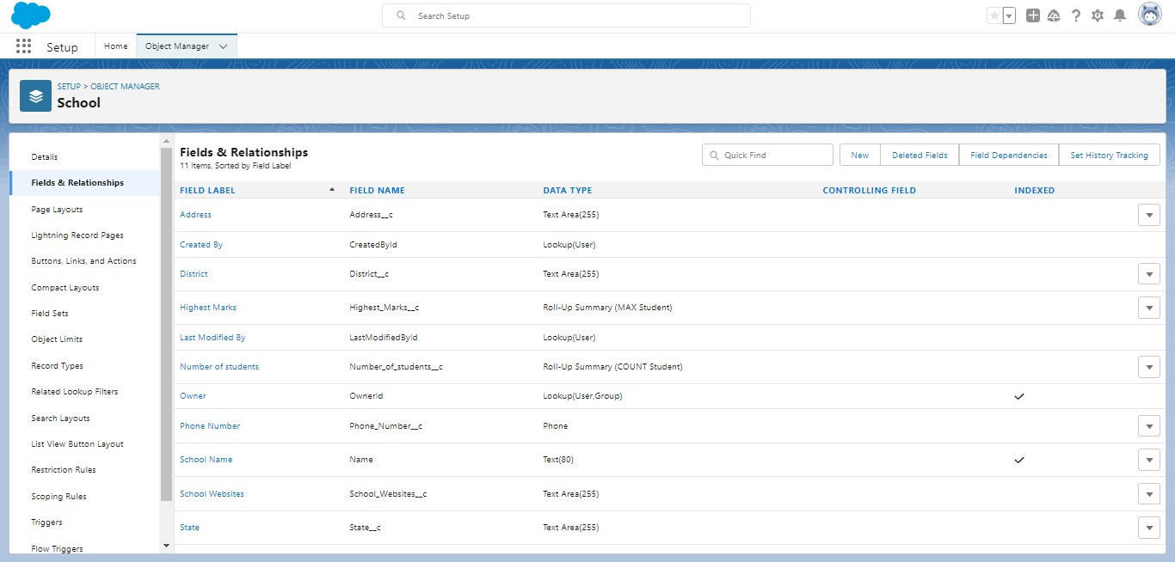

**FIELDS AND RELATIONSHIPS FOR STUDENT OBJECT:**

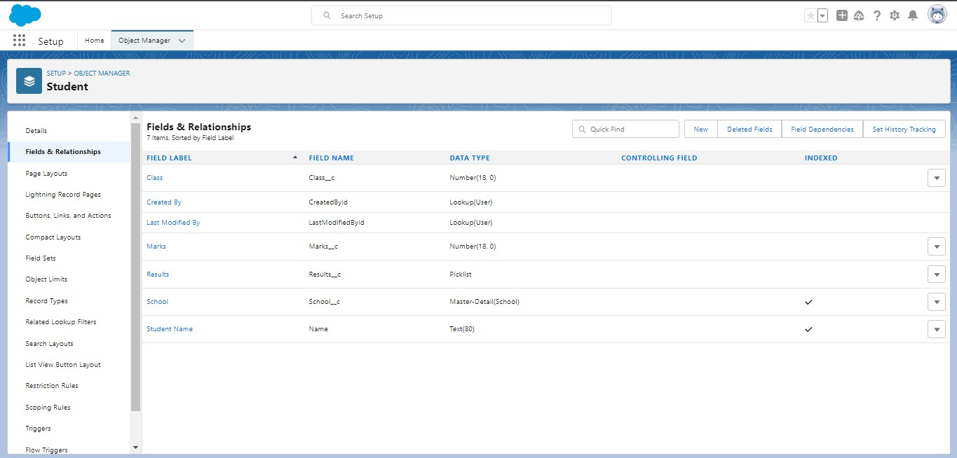

**FIELDS AND RELATIONSHIP FOR PARENT OBJECT:**

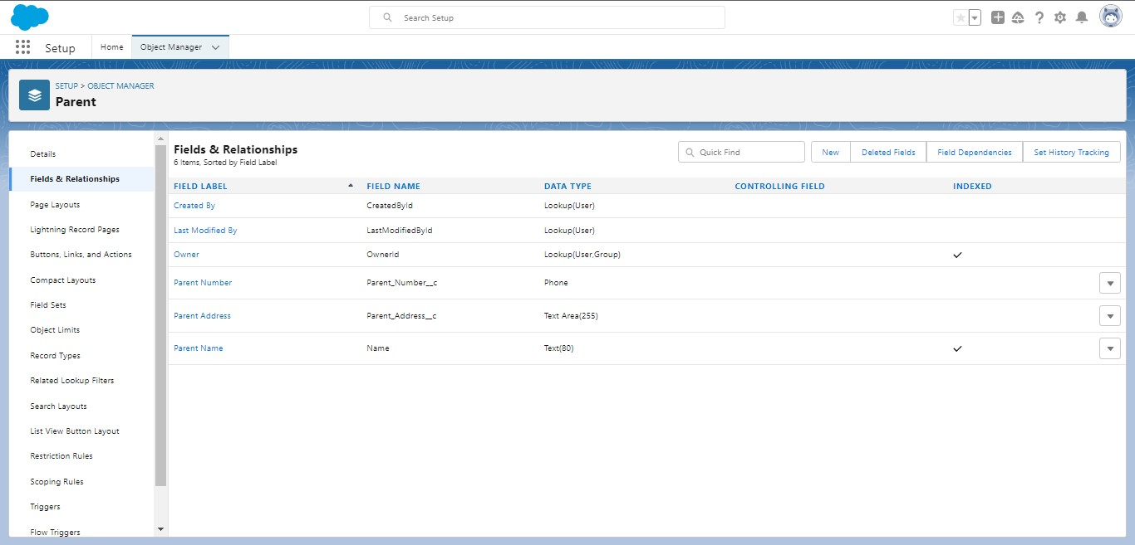

**ACTIVITY 4:**

**USER:**

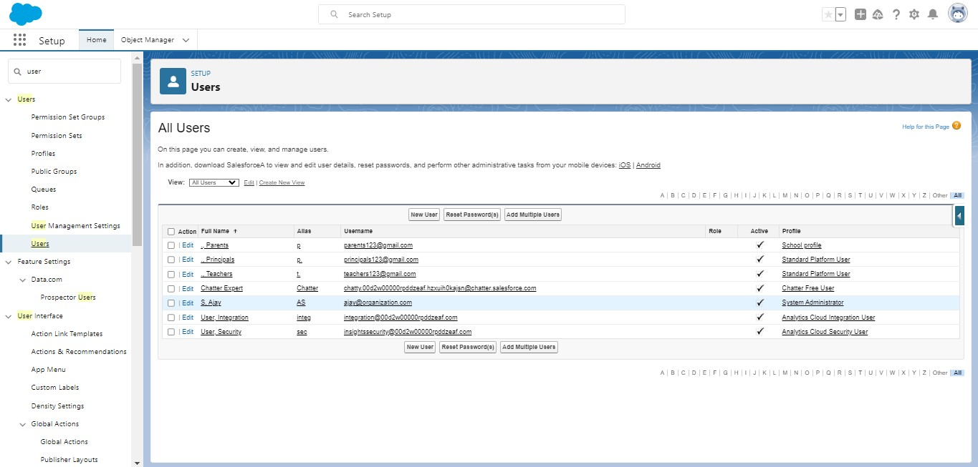

**ACTIVITY 5:**

**REPORTS:**

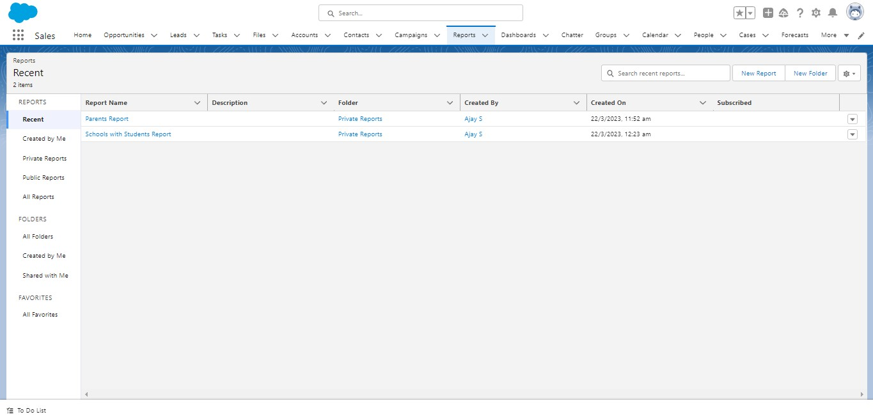

**4 Trailhead Profile Public URL**

**JOSHUA SHELTON J (TEAM LEAD)**

[**https://trailblazer.me/id/grjjs**](https://trailblazer.me/id/grjjs)

**CHANDRU D**

<https://trailblazer.me/id/chand1966>

PRABHAKAR S.P.

<https://trailblazer.me/id/prabha282100>

SOUNDARYA DEVI E

<https://trailblazer.me/id/soundaryadevi>

CRM Application for Schools/Colleges

1. **ADVANTAGES** 
   * Improved Communication Personalization
   * Streamlined Processes
   * Data Analytics
   * Improved Student Retention

The areas where this solution can be applied

**4 DISADVANTAGES**

* + Cost
  + Complexity
  + Data privacy
  + Resistance to change
  + Overemphasis on metrics
  + Risk of data silos

1. **APPLICATION** 
   * Student Recruitment
   * Admissions Management
   * Student Engagement
   * Fundraising
   * Alumni Relations
   * Faculty/Staff Management
2. **CONCLUSION**

CRM applications for schools and colleges are designed to help institutions manage their relationships with students, parents, and other stakeholders. These applications typically include features for managing student information, tracking enrollment and admissions, managing financial aid and scholarships, and communicating with students and parents. They may also include tools for tracking student performance, managing schedules and calendars, and providing analytics and reporting on student and institutional data. Some of the key benefits of CRM applications for schools and colleges include increased efficiency, improved communication, and better student outcomes.

CRM Application for Schools/Colleges

1. **FUTURE SCOPE**

Customer Relationship Management (CRM) applications for schools and colleges have a promising future. With the increasing demand for personalized education, CRM applications can help educational institutions to manage relationships with their students, faculty, and other stakeholders effectively. These applications can assist in tracking student progress, managing communication with parents and alumni, and automating administrative tasks such as scheduling and recordkeeping. Moreover, with the integration of artificial intelligence and machine learning, CRM applications can provide valuable insights to improve student engagement and learning outcomes. As educational institutions continue to prioritize student success, CRM applications will play an essential role in enhancing the overall educational experience.